# ABC Inventory Management

# Test Scenario: Beta Test Scenario 4

Table of Contents

ABC Inventory Management 1

Test Scenario: Beta Test Scenario 4 1

Scenario Description 3

Version Control 3

User Group 3

Test Log 3

Steps 3

Result Screenshots 4

Feedback 10

# Scenario Description

This is the fourth Beta test scenario of ABC Inventory Management. The test was conducted by a third-party user to check if they could use the system as they wanted. No scripts were prepared so that the user had complete freedom to conduct any activity they wished for. All activities conducted by the user were logged when the user was conducting the tests. These logs were observed and documented in this document by the author. The basic information of the application and a user manual was provided to the user. The user was also given a warehouse staff password and a store staff password.

# Version Control

|  |  |  |  |
| --- | --- | --- | --- |
| Version Number | Date | Author | Description |
| 12.0 | 02/10/2018 | Shirish Maharjan | Initial Draft |
| 12.1 | 11/10/2018 | Shirish Maharjan | First Version (Iteration 6) |

# User Group

* Nish Ranjitkar

# Test Log

## Steps

|  |  |  |  |
| --- | --- | --- | --- |
| Step | Test Action | Expected Results | Pass/Fail |
| 1. | Application is launched. | System displays the ‘Login’ Page with the Username and Password field empty. | Pass |
| 2. | User enters the provided warehouse staff username and password. | System waits for user to click on ‘Login’ button. | Pass |
| 3. | User clicks on the ‘Login’ button. | System grants access to the user and opens the Homepage with Warehouse Staff access. | Pass |
| 4. | User clicks on ‘Manage Staff’ button. | System displays the ‘Manage Staff’ page. | Pass |
| 5. | User clicks on the ‘Back’ button. | System displays the Homepage. | Pass |
| 6. | User clicks on the ‘Send Product’ button. | System displays the Send Product page. | Pass |
| 7. | User selects a store to send product and enters a description. | System waits for user’s action. | Pass |
| 8. | User selects the first item on the list of product items that is already displayed (Z2100) and clicks on the ‘Add to cart’ button. | System adds the selected item to the cart. | Pass |
| 9. | User double clicks on the quantity of the product item in the cart. | System makes the quantity editable. | Pass |
| 10. | User enters a desired quantity hits enter. | System updates the quantity in the cart. | Pass |
| 11. | User clicks on the ‘Send’ button. | System removes the entered quantity from the sending location (location where the user belongs to) and displays an appropriate message. | Pass |
| 12. | User clicks on Ok. | System displays a fresh send product page. | Pass |

### Result Screenshots

**Step 1**

Application launched, and login page is displayed.

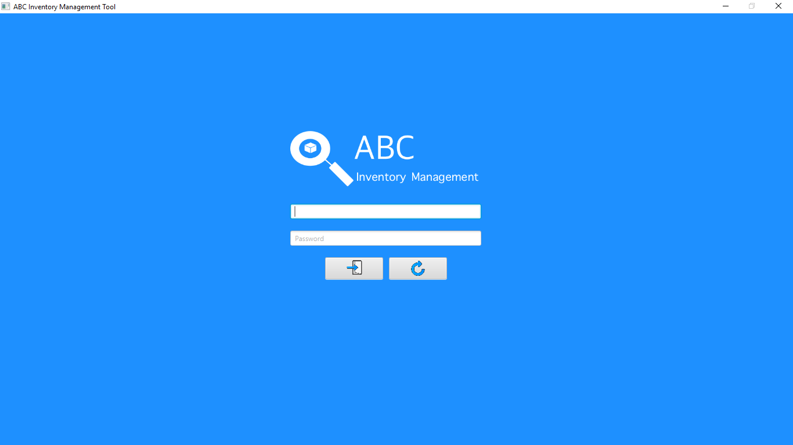

**Step 2**

Username and password are entered, and the system waits user to click on the ‘Login’ button.

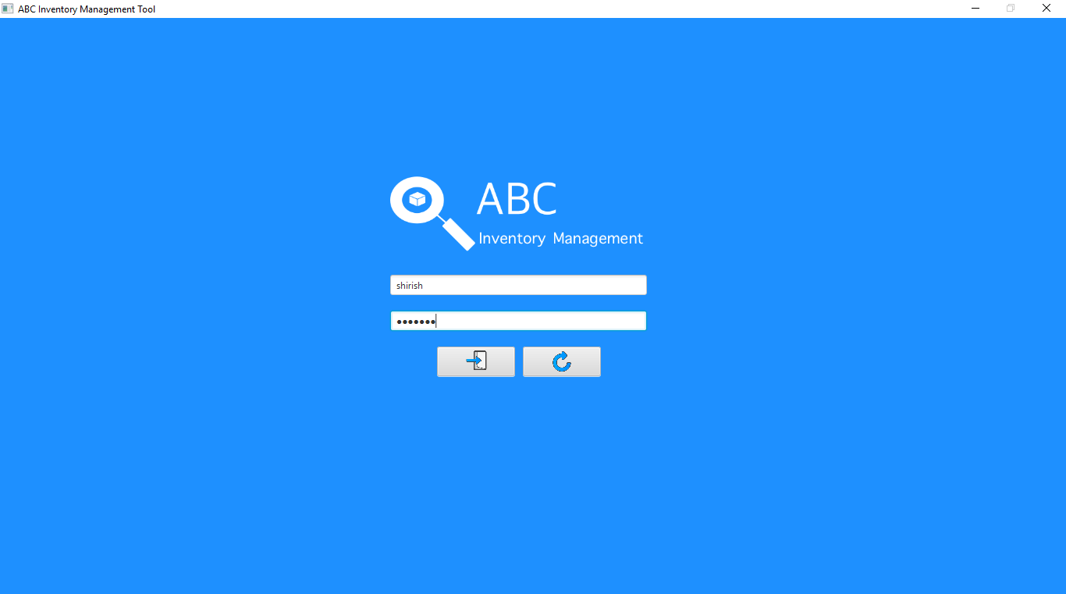

**Step 3**

After the user clicks on the login button, the homepage is displayed with warehouse staff access. The user then clicks on the ‘Manage Staff’ button.

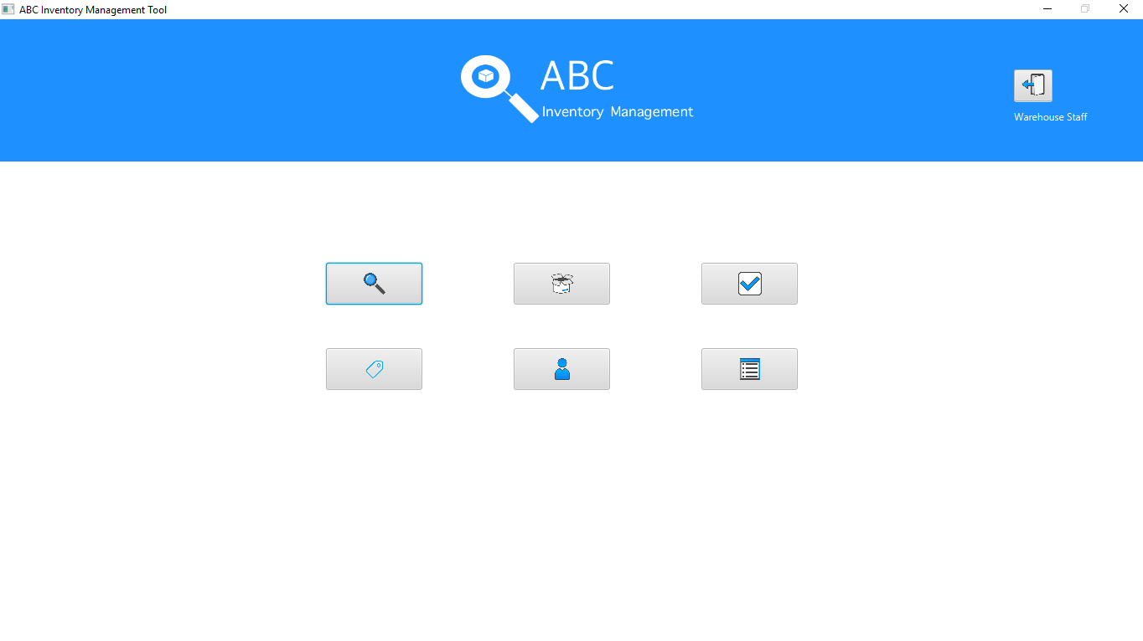

**Step 4**

After the user clicks on the ‘Manage Staff’ button, the manage staff page is displayed.

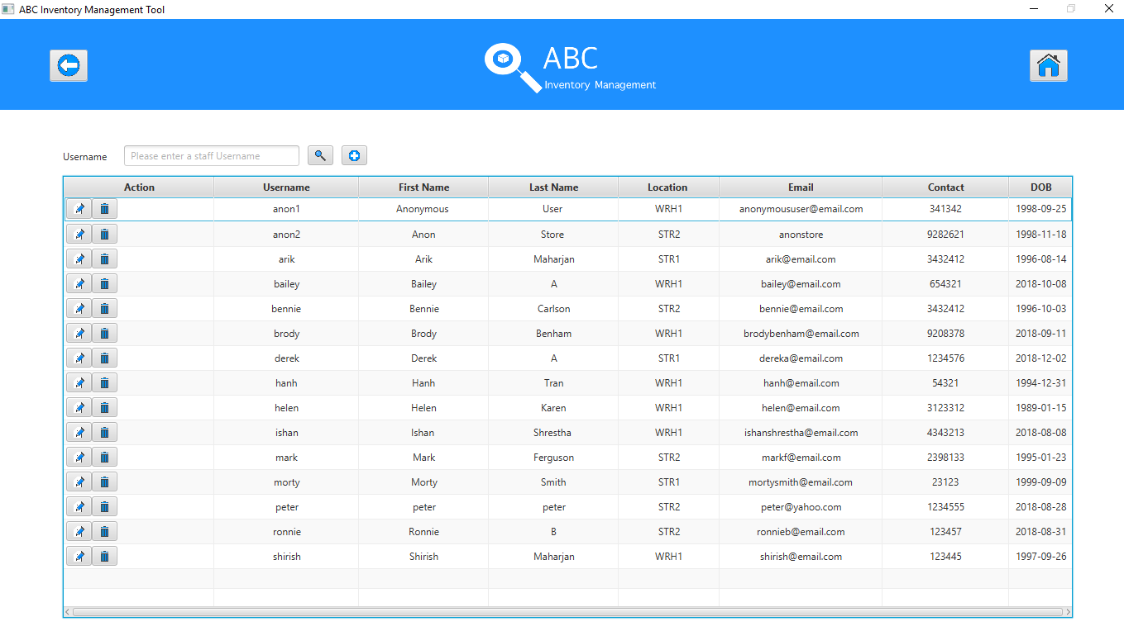

**Step 5**

The user when clicks on the back button, the homepage is displayed again.

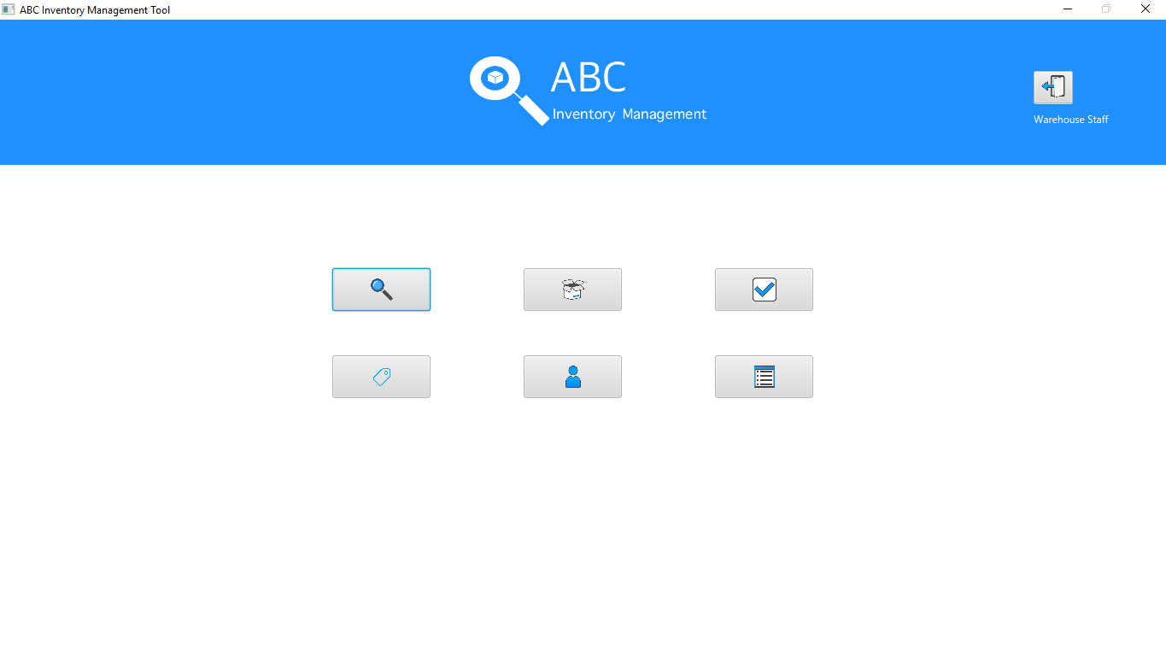

**Step 6**

The user then clicks on the ‘Send Product’ button after which the send product page is displayed.

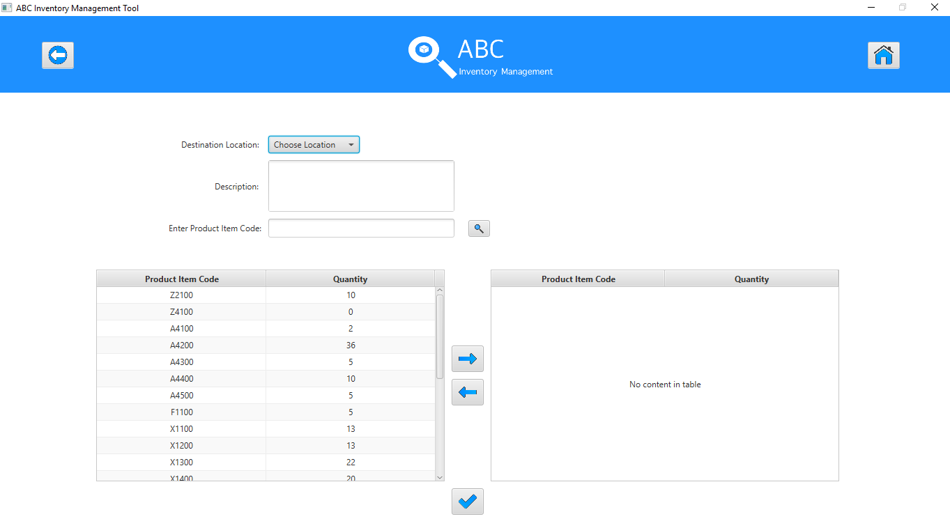

**Step 7**

The user selects a location to send products to and enters a description.

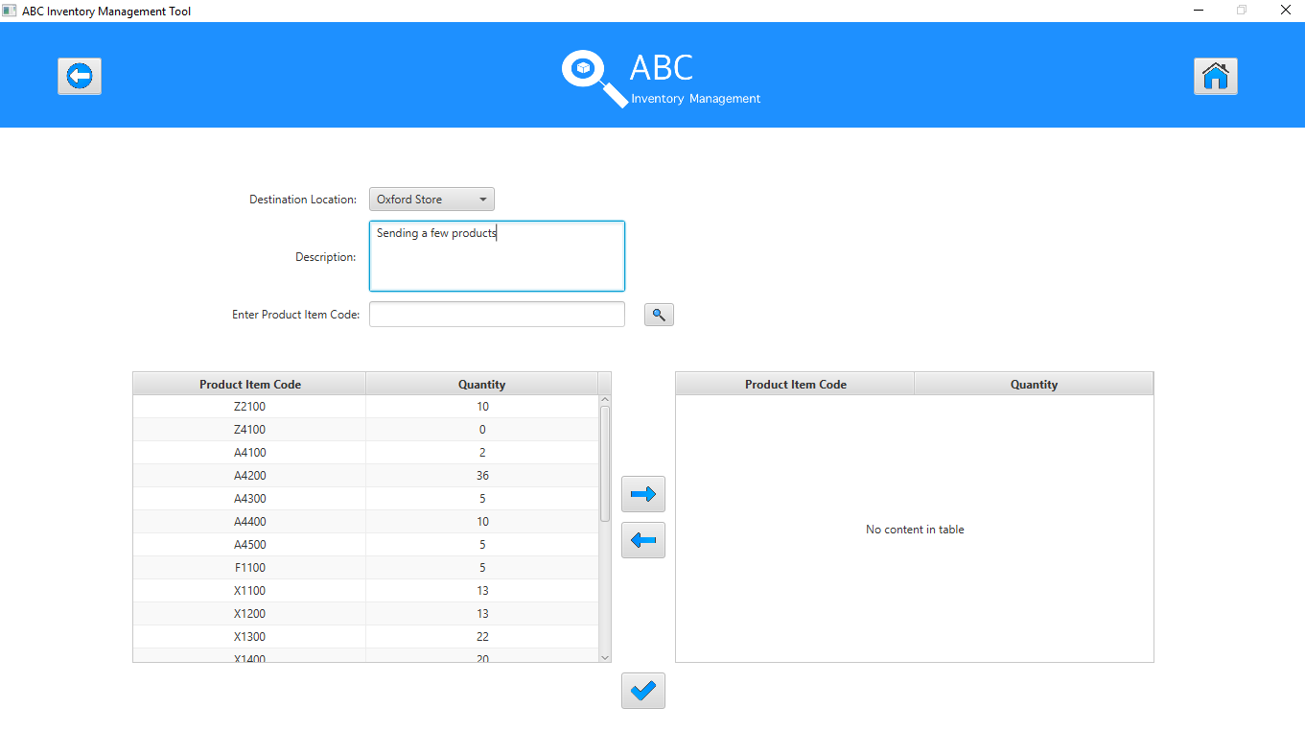

**Step 8**

The user selects the first item on the list of product items already displayed in the list. After this the user, clicks on the ‘Add to cart’ button.

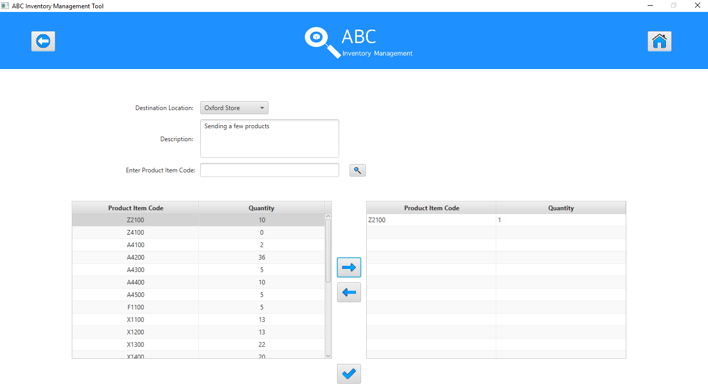

**Step 9**

The user then double clicks on the quantity of the product item in the cart.

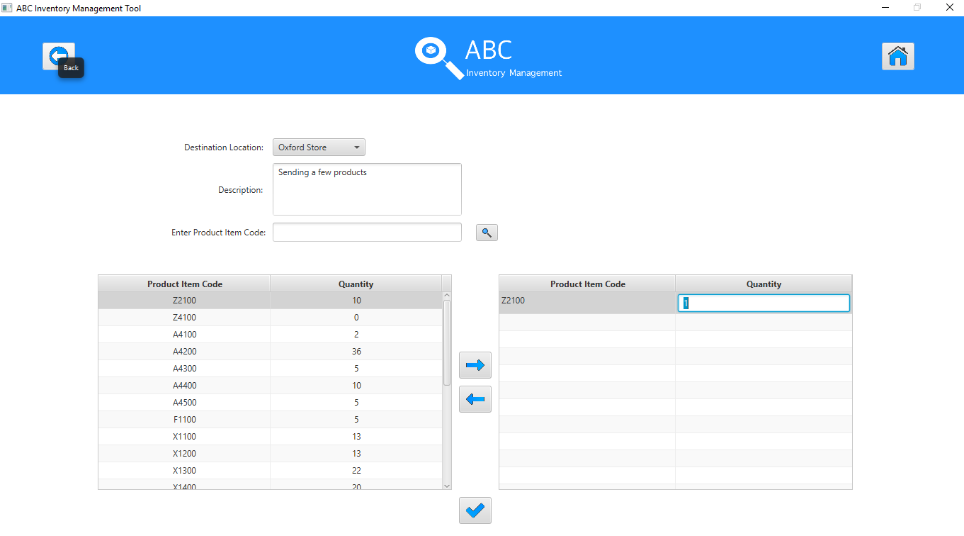

**Step 10**

User then enters a desired quantity and hits enter.

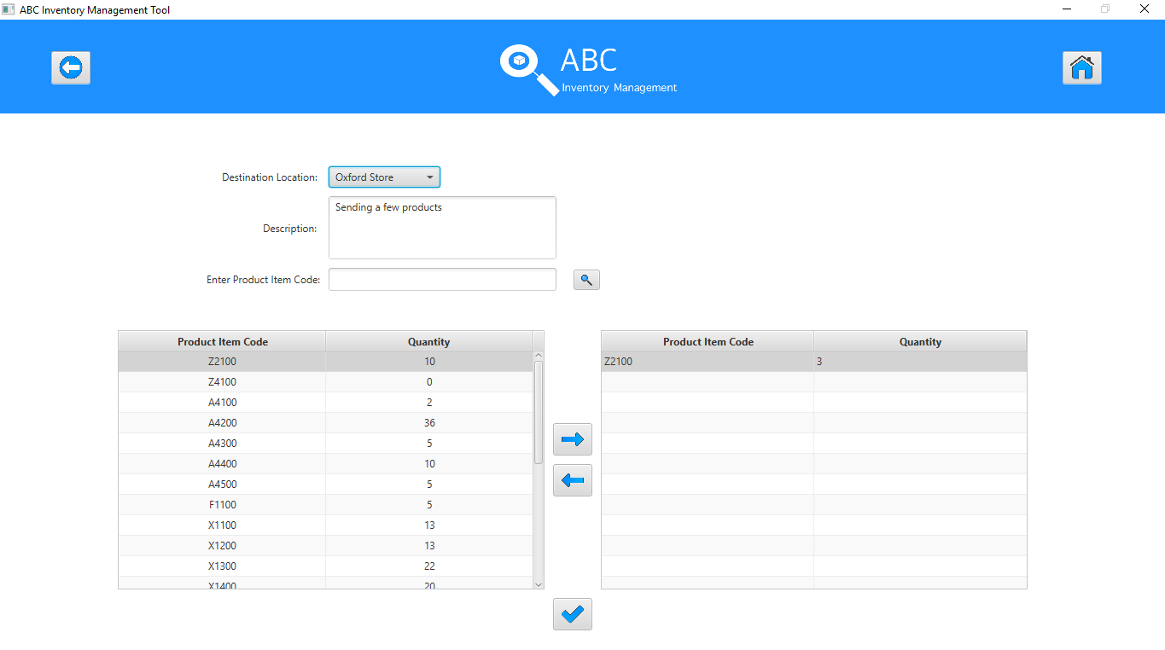

**Step 11**

When user clicks on the ‘Send’ button, the system updates the database accordingly and displays an appropriate message. This message has been updated from the previous version of ABC Inventory Application.

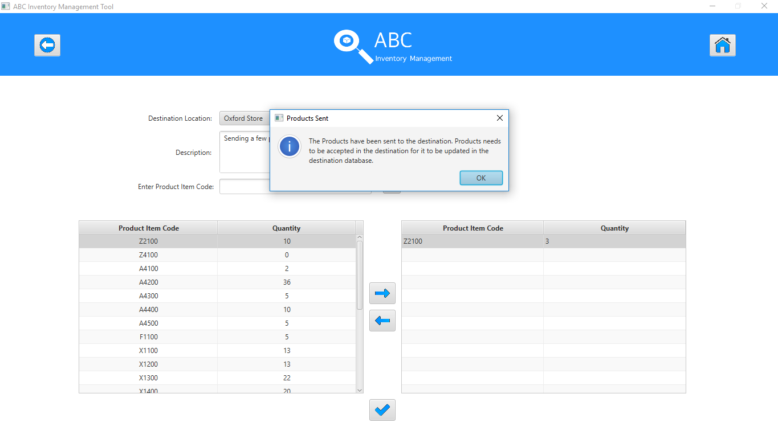

**Step 12**

After the user clicks on Ok, the system displays a fresh send product page.

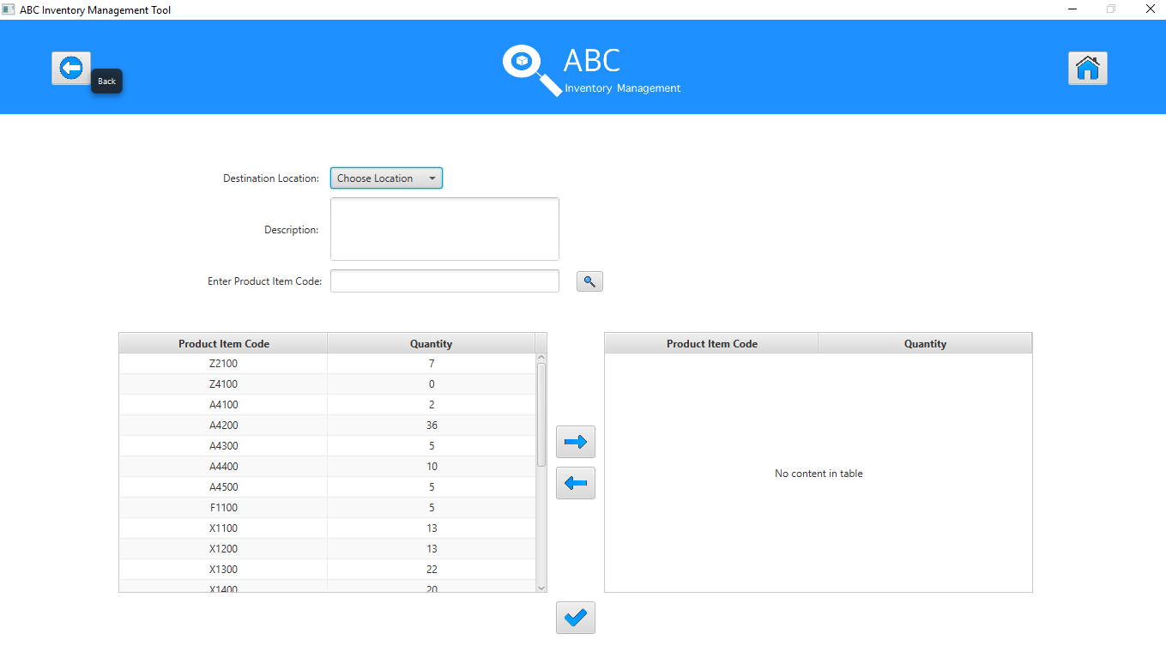

# Feedback

‘Application is good when used with the help of user manual. Obviously, it is going to be a bit confusing for me because it is my first time using the application, but I think I will get a hang of it. Some of the icons used might be made a bit bigger for users who have eye issues.’ -Nish Ranjitkar